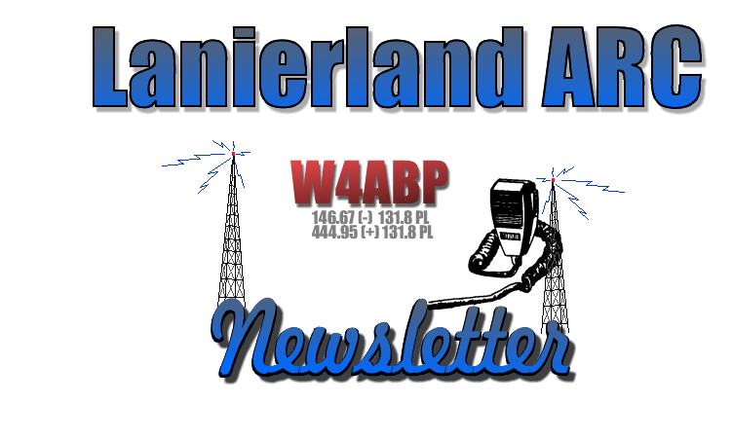
http://www.lanierlandarc.org December 2009 b

President’s Corner

“Season’s Greetings” LARC Members,
Now is the time of the year to let those AES and HRO catalogues lay around with your dream radio Circled boldly! Sometimes one must NOT be subtle about what we are wishing for! I can emphasize with you all, for my mobile is working intermittently, and I need to fix it or toss it. Aren’t those intermittents a devil of a time to find?
Santa are you listening?
It’s December and the Christmas/Hanukkah season is upon us. Certainly it is a time to reflect on our good fortune and to give thanks. It is also a time for sharing. Perhaps one of the greatest gifts we can share is our time and technical and operator knowledge of HAM radio. Have we “Elmered” anyone this year – either within or outside the club. Just because someone is a LARC member does not mean they don’t need some encouragement and assistance. Perhaps that is the reason they joined the LARC. If you need some help on a project don’t be afraid to ask the person next to you at the meeting. Most of us would like to help but are reluctant to offer just as others are reluctant to ask. The LARC is a tremendous resource – use it. And do offer to share your time and capabilities both within and outside the club. You will find it very rewarding.
I hope to see everyone at the Dec. 5th Christmas Breakfast.

Susan, Zack, and I wish everyone a very Merry Christmas and Happy New Year.
Until next time, 73 Philip K4PDL

2010 Club Officers Elected
President Philip Loggins, K4PDL
Vice President Mac Payne, WD4MP
Treasurer John Brandon, KE4PCF
Secretary Tom Keith, KJ4FQT
Activities Manager Perry Roper, KO4RD

2010 Directors
(3 Year) Larry Tyson W4WLT
(2 Year) Bob Scott KG4NJC
(1 Year) Doyle Gantt W4DJG

FOR SALE

Heathkit SB-201 HF amplifier. I installed all the Harbach mods ($200)... soft start, soft key, fan, meter protection, HV power supply. Nearly new matched 572B tubes. Works great, good reports. Wired for 110 vac. 450-500 watts PEP output. Works great, good reports. Manual and paperwork. Will demo. Purchased a AL-80B. $375 negotiable.

Yaesu FT-840 HF rig. 100 watts. Backup radio. Excess to needs. Arguably one of the best enty-level HF radios ever built. No menus to deal with. Mic, manual, tech manual, power cord. Will demo. $350 with power supply.
MFJ 993B autotuner. Works great. $125. Will demo.

Contact:

Mac Payne- WD4MP @ 678-617-2492 if your interested in any of the above items.

Interesting Contacts and Logs
Ed Cravey KF4HPY
A couple of months ago I was operating portable from the mountain cabin using my MFJ QRP radio on 40m on a weekend. I listened to several hams discussing some interesting subjects for a time while tuning around the band to get an idea of the propagation. On one band scan, I stopped the tuning dial on a station calling CQ and listened to the exchange between the special event station and the operator answering the call.

It was W9S for Steam Event touting the Sycamore IL Steam Expo. The Expo featured sawmills, tractors, stationary steam engines, and steam related machinery as used in the past. I listened to the exchanges for a time learning all the log items necessary to confirm a contact.

Upon hearing a CQ fromW9S, I answered and was picked up at once with a signal report of 58, not bad for 5W, and did our logging and he described some more of the exposition. A day earlier I came upon Lighthouse Special events. These stations were coming from all over the US and on other bands from the rest of the world.
I contacted a lighthouse station in Dunkirk NY, located between Erie PA and Buffalo NY.

I won’t be getting that certificate due to poor logging. What did I do wrong? To start with, I had no clock at the operating position, no calendar either and in my excitement I put down the wrong date and didn’t enter the time. Go on laugh, all of us have made mistakes before and never made that same error again. One of my friends made an overseas contact and failed to be confirmed. What happened? He always used EST instead of UTC, GMT or ZULU time as used by most DX operators. So, be advised, have a clock, calendar, pencil and paper, and be aware of the time difference between UTC as announced by WWV and your own local time.

That said, I was interested in special event stations and wondered where I could get information on them. It turned out the magazines QST and CQ have sections listing events for each month. Also the ARRL newsletters have a column also. A sample event listing is as follows: Call Sign, Location, Name of Event, Brief Description, Time and Dates, Frequencies and Modes, Name and Address for QSL and, if Certificate is offered, plus a request for a SASE (Self Addressed, Stamped Envelope). The ARRL web site also has a listing of special events with all the above entries. After you do the contact and send the QSL and SASE don’t expect an instant reply. I contacted a station in April and received the certificate in mid August. You must remember all the contacts must be confirmed, certificates printed, folded and mailed which in the case of hundreds of QSL’s equal a lot of time.

Once you have learned of a special event, maybe you will want to visit that event in person at some later date. Some of these are weeklong events with fireworks, parades, and other happenings. So let us get out that SSB mike, CW key, or PSK computer and have a little fun on the air. You just might enjoy working special events. Just remember to have log, clock, and calendar at hand; not like me operating portable with none of the aforementioned items at hand. Don’t forget the 10-10 awards, the SMIRKS, and other amateur organizations, they are also interesting.

73 and Good DX.



CLUB LOGO ITEMS

“SHOW YOUR TRUE CLUB COLORS”
(See John Brandon KE4PCF, supplies are limited)

Ball Caps with Embroidered Logo Embroidered
Patches
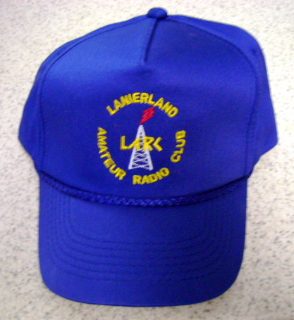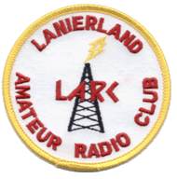
$10.00 $3.50

Special order golf and/or button up shirts are also available.

Club logo, name and call sign are embroidered.

See any club officer for more information.

Lunch Bunch Every Friday at 11:30 there is a lunch get-together at a local restaurant. The location is announced on the Wednesday night net, our web site under the activities tab and under the calendar icon as well as announced on the 146.67 repeater. Everyone is welcome!!!!
Next club meeting (December 5) will be located at Ryan’s Buffet, 2415 Browns Bridge Rd in Gainesville. Breakfast/Meeting 8:30-10:30 A.M.
ALL are welcome

Hall County Nets W4ABP repeater 146.67 (-) 131.8 Hz PL
Hall County ARES Net, Wednesday @ 20:00 & LARC Net, Wednesday @ 20:30
“Everyone is welcome to check in”

Note From The Editor
I produced my first issue of the LARC Newsletter on January 2008. This issue will be my last. The main reason that I have chosen to step down as newsletter editor is my belief that the LARC Web site <http://www.LanierlandARC.org/> can replace most, if not all, the newsletter’s functions and provide information in a more timely manner. The LARC Web site offers a vast variety of information to keep our members well informed plus share information and is indeed a great tool for doing just that.

I agreed to assume the editor task with the belief that a monthly newsletter was important for our group. During the course of the past 24 months, that notion has completely reversed and I now see a totally new prospective. In short, I truly believe our web site is a much better avenue to share information, not only within our group, but the rest of the world as well.

If someone else wants to pick up the Newsletter editorship that's fine, but I'm convinced that
transition to an online vehicle makes sense and is entirely consistent with the nature and mission of our organization at this time. During my thought process, I hashed over the issue of those who do not have internet access. I soon realized it’s a mute point since the newsletter is posted on the reflector each month and is archived on LARC’s website. Those who do not have internet access don’t see the newsletter or messages from the reflector anyway.

Thank you for your support over the past 2 years especially those who provided written input to include within the pages of the newsletter.

Special thanks to Mr. Ed KF4HPY for his effort to provide interesting articles every single month I worked on the newsletter. WELL DONE ED

Merry Christmas and 73 to all
Doyle Gantt W4DJG

As a reminder, newsletters are archived within our web-site. Each issue is listed with the most recent edition first. http://www.lanierlandarc.org/newsletters.html

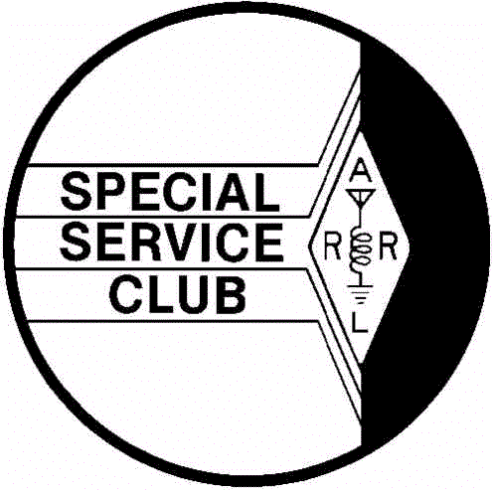
Lanierland Amateur Radio Club
PO BOX 2182
Gainesville, Georgia 30503

“REMEMBER THE REASON FOR THE SEASON”


